 



Dairy Science Club

The Pennsylvania State University

Department of Animal Science

335 Ag Sciences and Industries

University Park, PA 16803

**College of Agricultural Sciences**

Dear Friends,

Greetings from the Penn State Dairy Science Club. It is hard to believe the holiday season is just around the corner! It is yet again that time of year to choose the perfect holiday gift...a **Penn State Dairy Science Club Holiday Cheese box.** Nothing quite roars “We Are” than a variety of Creamery Cheeses and Spreads.

We are excited again this year to work with the Penn State Berkey Creamery to offer our Holiday Cheese Box with three Creamery cheddar cheese varieties, along with their famous Pimento Spread and smooth Cream Cheese. The Berkey Creamery will be cutting and packaging the cheese, and our club members will pack boxes and fill orders. We want to thank you in advance for your continued support of the Dairy Science Club and our annual Holiday Cheese Sale. We look forward to working with you and want to wish you a wonderful holiday season.

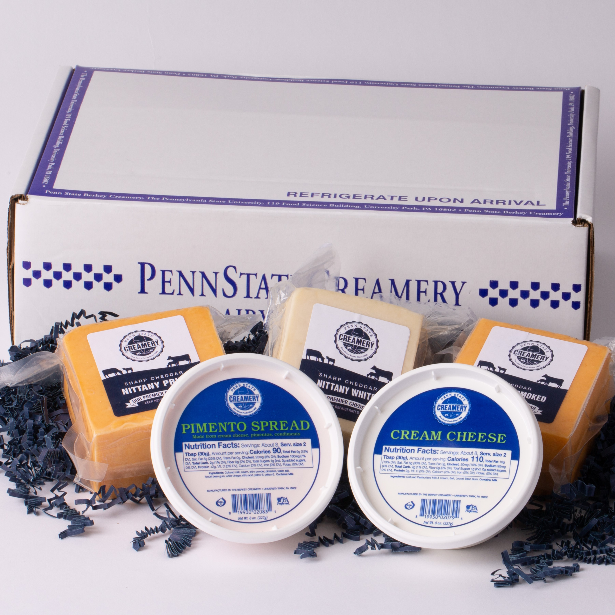Please note that for your ordering convenience, you can use the attached order form or receive an electronic order form at http:/animalscience.psu.edu (look for **Cheesebox Sale** under **Upcoming Events** at the left side of the page). **Please also note our order deadline of November 25th.**

**Holiday Cheese Box includes:**

* Penn State Creamery **Nittany White Cheddar**
* Penn State Creamery **Nittany Yellow Cheddar**
* Penn State Creamery **Nittany Smoked Cheddar**
* Penn State Creamery Pimento Spread (8oz)
* Penn State Creamery Cream Cheese (8oz)

**How to Order:**

|  |  |  |  |
| --- | --- | --- | --- |
| **Ordering Method** | **Payment Options** | **Fulfillment Options** | **Instructions** |
| **Mail in Order Form** **or Email Order Form**  **-Pickup- $42 -East- $58 -West/South- $66** (determined by address)  **-Discount for 20 or more orders** | -**Check** (submit check with order form if shipping) | -**Shipped via UPS**   -**Pickup**  Pay by cash or check at pickup. Pickup days are Thursday, December 12 from 3-6 p.m and Saturday, December 14 from 9 am-2 pm.  We will email information about pickup at the rear of the Food Science Building. | **-Email order form to:** [cheeseboxes@gmail.com](mailto:cheeseboxes@gmail.com)   **-Mail payment to:** Penn State Dairy Science Club  c/o Cheesebox Sale  335 Ag Sciences and Industries Bldg. University Park, PA 16802  **-Make checks payable to: Penn State Dairy Science Club** |

**Additional Information:**

* **QUESTIONS?** 
  + **Email us at** [**cheeseboxes@gmail.com**](mailto:cheeseboxes@gmail.com)
  + **Call us at (570) 575-9573 from 9 am-5 pm**
* **Order deadline is Monday, November 25th**
* **All on-time orders will be shipped no later than Tuesday, December 17th**
* **Discounted orders: Order 20 or more boxes, receive a lower price**